Supplementary Information
Targeting Infected Host Cells in vivo via Responsive Azido-Sugar Mediated Metabolic Cell Labeling Followed by Click Reaction
Yang Boª, Yunjiang Jiangª, Kangmei Chen^{c}, Kaimin Caiª, Wenming Liª, Jarron Roy^{b}, Yan Bao^{c,a}*, Jianjun Cheng ^{a,b}*

ª Department of Materials Science and Engineering, ^{b} Department of Bioengineering, University of Illinois at Urbana-Champaign, Urbana, Illinois 61801, United States, ^{c} Medical Research Center, Sun Yat-Sen Memorial Hospital, Sun Yat-Sen University, Guangzhou, Guangdong 510120, P.R. China

*Corresponding Author: jianjunc@illinois.edu, baoy5@mail.sysu.edu.cn

Materials and Methods
Materials. All chemicals purchased from Sigma-Aldrich (St. Louis, MO, USA), Thermo Fisher Scientific (Waltham, MA, USA) or Chem-Impex (Wood Dale, IL, USA) were reagent grade and used without further purification unless otherwise stated. DBCO-Cy5 was purchased from Click Chemistry Tools (Scottsdale, AZ, USA). Phosphate-buffered saline (PBS) and Dulbecco’s Modified Eagle Medium (DMEM) were obtained from Invitrogen (Carlsbad, CA, USA). Fetal Bovine Serum (FBS) was purchased from Lonza Walkersville Inc. (Walkersville, MD, USA). BD Falcon culture plates were purchased from Fisher Scientific (Hampton, NH, USA). ProLong Gold antifade reagent was purchased from Life Technologies (Carlsbad, CA, USA). Anhydrous dichloromethane (DCM), tetrahydrofuran (THF) and dimethylformamide (DMF) were prepared by passing the solvent through alumina columns. Rb polyclonal antibody to CD68 and Goat anti-Rb IgG-Alexa Fluorophore 555 were purchased from Abcam (Cambridge, MA, USA). DBCO–PEG₄–biotin, streptavidin–horseradish peroxidase (HRP), and Pierce ECL western blotting substrate were purchased from Thermo Fisher Scientific (Waltham, MA, USA).
Instrumentation. High performance liquid chromatography (HPLC) analysis was performed on a Shimadzu CBM-20A system (Shimadzu, Kyoto, Japan) equipped with an SPD-20A PDA detector (190–800 nm), a RF-20A fluorescence detector, and an analytical C18 column (Shimadzu, 3 μm, 50 × 4.6 mm, Kyoto, Japan). Preparative HPLC was performed on a CombiFlash®R_{f} system (Teledyne ISCO, Lincoln, NE, USA) equipped with a RediSep®R_{f} HP C18 column (Teledyne ISCO, 30 g, Lincoln, NE, USA). Lyophilization was conducted in a Labconco FreeZone lyophilizer (Kansas City, MO, USA). Nuclear Magnetic Resonance (NMR) spectra were recorded on a Varian U500 (500 MHz) or VXR500 (500 MHz) or a Bruker Carver B500 (500 MHz) spectrometer. Electrospray ionization (ESI) mass spectra were obtained from a Waters ZMD Quadrupole Instrument (Waters, Milford, MA, USA). Flow cytometry analysis was conducted on a BD FACS Canto 6-color flow cytometry analyzer (BD, Franklin Lakes, NJ, USA) or a BD AccuriTM C6 Flow Cytometer (BD, Franklin Lakes, NJ, USA). Confocal laser scanning microscopy (CLSM) images were taken by using a Zeiss LSM 700 Confocal Microscope (Carl Zeiss, Thornwood, NY, USA). Western blotting protein bands were imaged on an ImageQuant LAS 4000 gel imaging system (GE, Pittsburgh, PA, USA). In vivo and ex vivo images of animals and tissues were taken on a Bruker In Vivo Imaging System (Bruker, Billerica, MA, USA). Frozen tumor tissues were embedded with optimum cutting temperature (O.C.T.) compound (Sakura Finetek USA, Torrance, CA, USA), sectioned by a Leica CM3050S Cryostat, and mounted onto glass slides.
Cell culture. RAW264.7 and CHO cells were purchased from American Type Culture Collection (Manassas, VA, USA). Cells were cultured in DMEM containing 10% FBS, 100 units/mL Penicillin G and 100 μg/mL streptomycin (Invitrogen, Carlsbad, CA, USA) at 37 °C in 5% CO₂ humidified incubator. ATCC12608 (S. aureus), MG1655 (E. coli), DH5α (E. coli) transformed with Prs426-TEF1-GFP plasmid (provided by Professor Huimin Zhao’s laboratory, UIUC), B. Subtilis bAB185 [ftsZ::mNeonGreen-15aa-ftsZ] (provided by Professor Paul Hergenrother’s laboratory, UIUC) were grown in Luria Broth (LB) medium at 37 ºC.
Animals. Female BALB/c mice (6-8 weeks old) were purchased from Charles River (Wilmington, MA, USA). Feed and water were available ad libitum. Artificial light was provided in a 12 h/12 h cycle. The animal protocol was reviewed and approved by the Illinois Institutional Animal Care and Use Committee (IACUC) of University of Illinois at Urbana-Champaign.
Synthesis of Ac₄GalNAz
Ac₄GalNAz was synthesized based on modified protocol from literature report. ¹ Bromoacetic acid (10 g, 71.9 mmol) was dissolved in deionized (DI) water (50 mL), followed by the addition of sodium azide (9.35 g, 143.0 mmol). The mixture was stirred at room temperature for 24 h. The resulting solution was adjusted to pH 1 by dropwise addition of hydrogen chloride solution (1 mol/L), and then extracted with diethyl ether (3 × 100 mL). The organic phase was collected, dried over anhydrous sodium sulfate, and concentrated to yield 2-azidoacetic acid (70% yield, 5.13 g). 2-Azidoacetic acid (5.13 g, 58.7 mmol) and N, N'-dicyclohexylcarbodiimide (12.09 g, 58.7 mmol) were dissolved in anhydrous THF, followed by dropwise addition of N-hydroxysuccinimide (6.75 g, 58.7 mmol) in THF. The mixture was stirred at room temperature for 24 h. The precipitate was filtrated, the solvent was removed to yield a yellow solid. The crude product was recrystallized from acetonitrile to obtain N-(2-azidoacetyl) succinimide as a white solid (52% yield, 6.05 g). D-Galactosamine hydrochloride (3.19 g, 14 mmol) and triethylamine (1.41 g, 14 mmol) were dissolved in methanol (100 mL), followed by dropwise addition of N-(2-azidoacetyl) succinimide (5.0 g, 25 mmol) in methanol (50 mL). The mixture was stirred at room temperature for 24 h. The solvent was removed under reduced pressure. The residue was re-dissolved in pyridine (50 mL), to which acetic anhydride (20 mL) was added. The reaction mixture was stirred at room temperature for another 24 h. After removal of the solvent, the crude product was purified by silica gel column chromatography using ethyl acetate/hexane (1/1, v/v) as the eluent to yield a white solid (65% yield, 3.9 g). ¹H NMR (500 MHz, CDCl₃): δ 6.37 (d, J = 9.5 Hz, 1H), 6.28 (d, J = 9.0 Hz, 1H), 6.21 (d, J = 2.1 Hz, 1H), 5.76 (d, J = 8.8 Hz, 1H), 5.44 (d, J = 3.4 Hz, 1H), 5.38 (d, J = 2.6 Hz, 1H), 5.24 (dd, J = 3.4 Hz, 11.6 Hz, 1H), 5.21 (dd, J = 3.4 Hz, 11.4 Hz, 1H), 4.68 (m, 1H), 4.36 (dt, J = 9.1 Hz, 11.2 Hz, 1H), 4.25 (t, J = 6.6 Hz, 1H), 4.14 (m, 1H), 4.08 (m, 1H), 4.07 (m, 1H), 3.94 (s, 2H), 3.92 (s, 2H), 2.17 (s, 3H), 2.16 (s, 3H), 2.15 (s, 3H), 2.12 (s, 3H), 2.04 (s, 3H), 2.02 (s, 3H), 2.02 (s, 3H), 2.01 (s, 3H), ¹³C NMR (125 MHz, CDCl₃): δ 171.1, 170.5, 170.4, 170.4, 170.2, 170.1, 169.4, 168.9, 167.1, 167.0, 92.4, 90.9, 71.9, 70.0, 68.7, 67.6, 66.6, 66.3, 61.3, 61.2, 52.6, 52.5, 50.1, 47.0, 20.9, 20.8, 20.7, 20.7, 20.7, 20.6, 20.6, 20.6. LRMS (ESI) m/z: calculated for C₁₆H₂₂N₄O₁₀ [M + Na] ⁺ 453.1, found 453.1.

Synthesis of MBTAAG
To an ice-bath cooled solution of Ac₄GalNAz (200 mg, 0.465 mmol) in anhydrous DCM (2 mL) was added boron trifluoride etherate (360 μL, 2.79 mmol). The mixture was stirred for 5 min. 4-Methoxybenzylmercaptan (115.5mg, 0.93 mmol) was then dropwise added to above solution. The mixture was stirred for 24 h at rt. After the removal of the solvent, the crude product was purified by silica gel column chromatography using DCM/hexane (1/1, v/v) as the eluent to yield a white solid (78% yield, 190.0 mg). ¹H NMR (500 MHz, CDCl₃): δ 7.39 – 7.30 (m, 5H), 6.69 (d, J = 9.0 Hz, 1H), 5.27 (dd, J = 10.1, 4.2 Hz, 1H), 5.16 (t, J = 10.0 Hz, 1H), 5.02 (s, 1H), 4.63 (dd, J = 9.1, 4.1, 1.3 Hz, 1H), 4.40 (ddd, J = 9.9, 4.5, 2.3 Hz, 1H), 4.26 (dd, J = 12.4, 4.6 Hz, 1H), 4.04 (dd, J = 17.2, 15.7 Hz, 2H), 3.99 – 3.96 (m, 1H), 3.78 (q, J = 13.7 Hz, 2H), 2.15 (s, 3H), 2.08 (s, 3H), 1.98 (s, 3H). ¹³C NMR (125 MHz, CDCl₃): δ 170.51, 169.91, 169.72, 166.20, 136.78, 128.97, 128.73, 127.53, 82.17, 69.91, 68.81, 65.87, 62.07, 52.44, 50.93, 34.85, 20.72, 20.69. HRMS (ESI) m/z: calculated for C₂₂H₂₉N₄O₉S [M + H] ⁺ 525.1655, found 525.1667.

Synthesis of BTAAG
To an ice-bath cooled solution of Ac₄GalNAz (200 mg, 0.465 mmol) in anhydrous DCM (2 mL) was added boron trifluoride etherate solution (360 μL, 2.79 mmol). The mixture was stirred for 5 min. Benzylmercaptan (143mg, 0.93 mmol) was then dropwise added to above solution. The mixture was stirred for 24 h at rt. After the removal of the solvent, the crude product was purified by silica gel column chromatography using DCM/hexane (1/1, v/v) as the eluent to yield a white solid (85% yield, 195.9 mg). ¹H NMR (500 MHz, CDCl₃): δ 7.39 – 7.30 (m, 5H), 6.69 (d, J = 9.0 Hz, 1H), 5.27 (dd, J = 10.1, 4.2 Hz, 1H), 5.16 (t, J = 10.0 Hz, 1H), 5.02 (s, 1H), 4.63 (dd, J = 9.1, 4.1, 1.3 Hz, 1H), 4.40 (ddd, J = 9.9, 4.5, 2.3 Hz, 1H), 4.26 (dd, J = 12.4, 4.6 Hz, 1H), 4.04 (dd, J = 37.2, 15.7 Hz, 2H), 3.99 – 3.96 (m, 1H), 3.78 (q, J = 13.7 Hz, 2H), 2.15 (s, 3H), 2.08 (s, 3H), 1.98 (s, 3H).¹³C NMR (125 MHz, CDCl₃): δ 170.5, 169.9, 169.72, 166.20, 136.78, 128.97, 128.73, 127.53, 82.17, 69.91, 68.81, 65.87, 62.07, 52.44, 50.93, 34.85, 20.72, 20.69. HRMS (ESI) m/z: calculated for C₂₁H₂₆N₄O₈SNa [M + Na] ⁺ 517.1368, found 517.1369.

Synthesis of MPTAAG
Under 0 ˚C, to a solution of Ac₄GalNAz (200 mg, 0.465 mmol) in 2 mL anhydrous DCM was added boron trifluoride etherate solution (360 µL, 2.79 mmol). The mixture was stirred for 5 min. Then, 4-methoxybenzenethiol (130.4 mg, 0.93 mmol) was dropwise added to above solution. The mixture could recover to room temperature and stirred for 24 hours. After the removal of the solvent, the crude product was purified by silica gel column chromatography using DCM/hexane (1/1, v/v) as the eluent to yield a white solid (62% yield, 147.5 mg. ¹H NMR (500 MHz, CDCl₃): δ 7.39 (d, J = 8.1 Hz, 2H), 7.15 (d, J = 8.3 Hz, 2H), 6.74 (d, J = 9.0 Hz, 1H), 5.40 – 5.27 (m, 2H), 5.20 (t, J = 10.0 Hz, 1H), 4.86 (dd, J = 9.0, 4.1, 1.4 Hz, 1H), 4.64 (ddd, J = 9.9, 5.1, 2.2 Hz, 1H), 4.29 (dd, J = 12.3, 5.2 Hz, 1H), 4.14 (dd, J = 12.3, 2.3 Hz, 1H), 4.10 (d, J = 16.6 Hz, 1H), 4.03 (d, J = 16.7 Hz, 1H), 2.36 (3, 2H), 2.11 (3, 1H), 2.10 (s, 3H), 2.03 (3, 2H). ¹³C NMR (125 MHz, CDCl₃): δ 170.48, 169.93, 169.77, 166.33, 138.65, 132.63, 130.05, 128.77, 86.95, 69.63, 69.22, 66.00, 62.23, 52.50, 51.30, 21.16, 20.71, 20.62. HRMS (ESI) m/z: calculated for C₂₁H₂₇N₄O₈S [M + H] ⁺ 511.1499, found 517.1501.
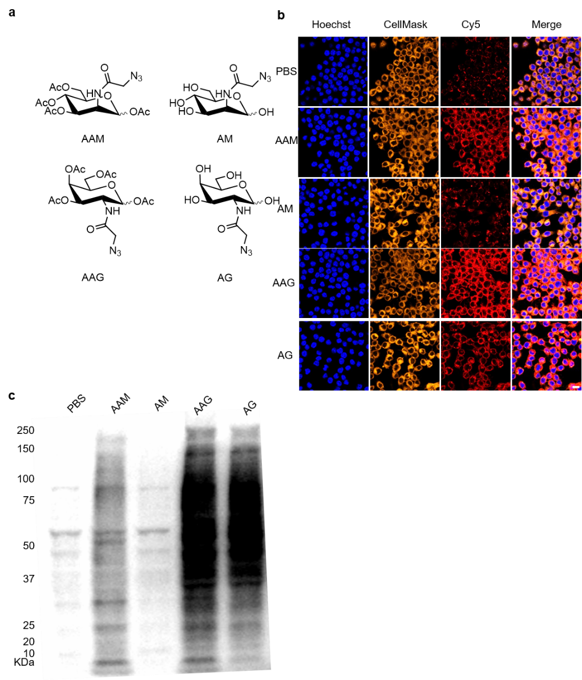

Figure. S1 (a) The molecular structure of the tested azido sugar precursors: Ac₄ManNAz (AAM), ManNAz (AM), Ac₄GalNAz (AAG) and GalNAz (AG). (b) CLSM images of labeled macrophages from different azido sugar treated groups. Cells were incubated with corresponding sugar for 24 h, and then labeled with DBCO-Cy5 (20 µM, red) for 1 h. Cell nuclei and membrane were stained with Hoechst 33342 (blue) and CellMask orange plasma membrane stain (orange). Scale bar, 20 µm. (c) The Western blotting analysis of murine RAW264.7 cells treated with: Ac₄ManNAz (AAM), ManNAz (AM), Ac₄GalNAz (AAG) and GalNAz (AG) for 24 h, respectively. The azido modified proteins were first biotinylated by incubating with DBCO-PEG₄-biotin, and then detected by streptavidin-horseradish peroxidase conjugate.

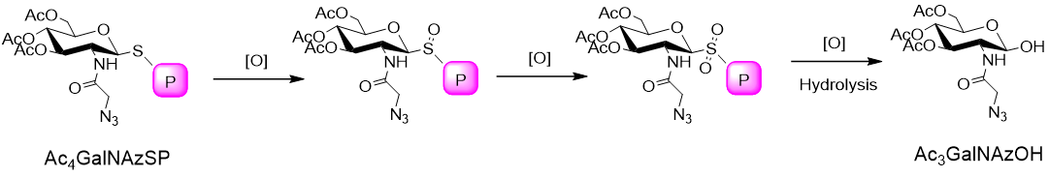

Figure. S2 Mechanism of Ac₃GalNAzSP degradation under overexpressed reactive oxygen species level.

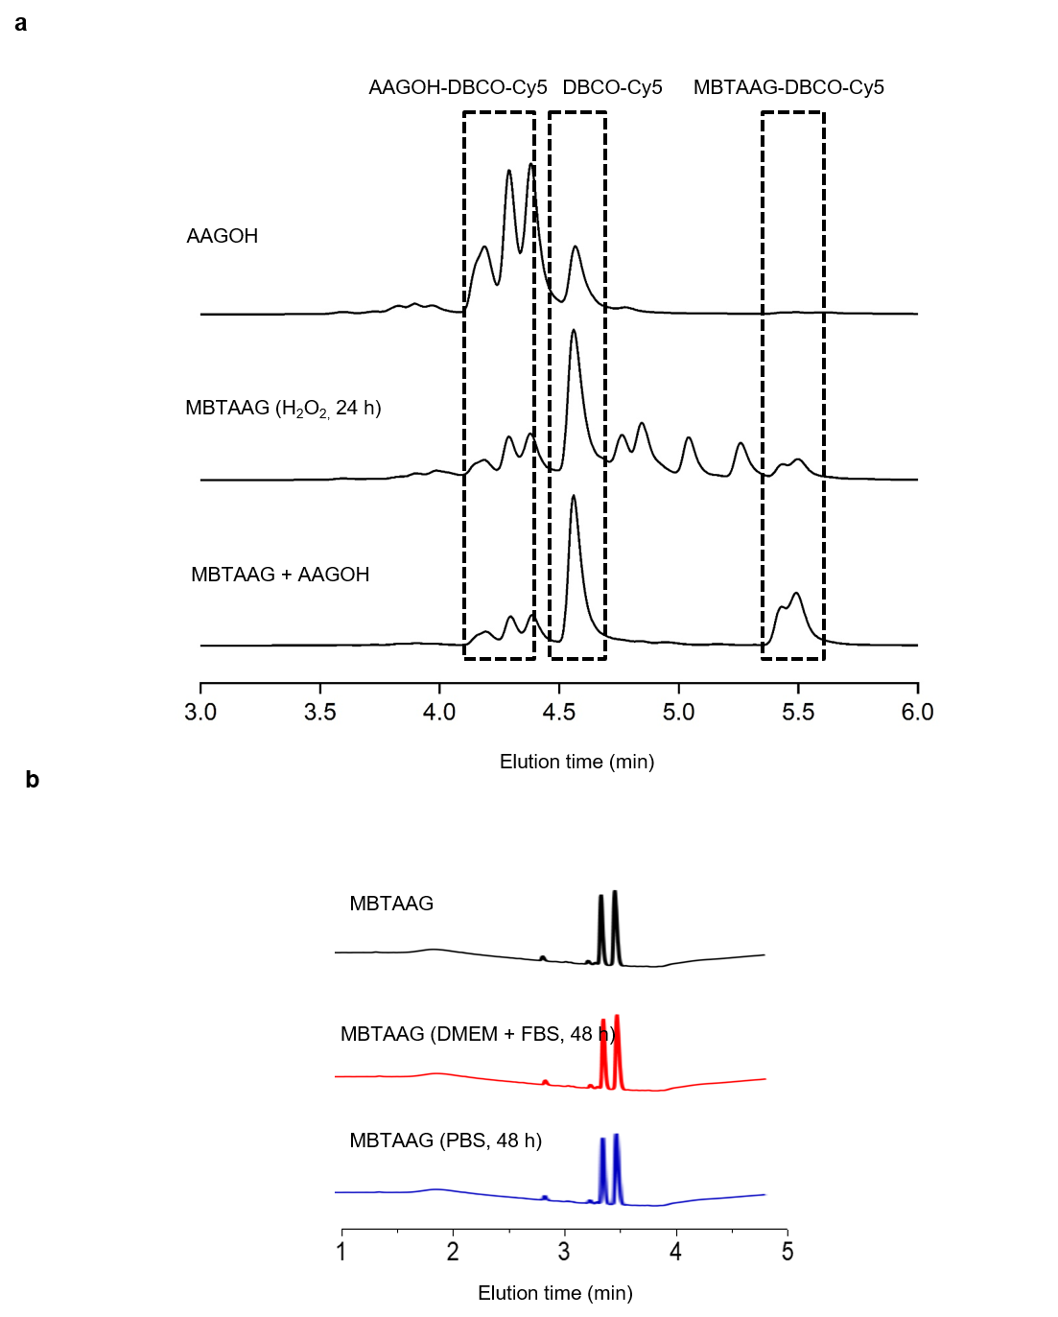
Figure. S3 (a) HPLC trace of MBTAAG and AAGOH after coincubation with DBCO-Cy5. Representative release of MBTAAG in H₂O₂ (24 hours) trace was also presented. H₂O₂ was quenched with excessive sodium pyruvate then co-incubate with DBCO-Cy5. Fluorescence detector: excitation: 650 nm, emission: 688 nm. (b) HPLC trace of MBTAAG and after 48 hours storage in PBS or DMEM cell medium containing 10% FBS at 37 ºC. PDA detector: 254 nm UV absorbance.
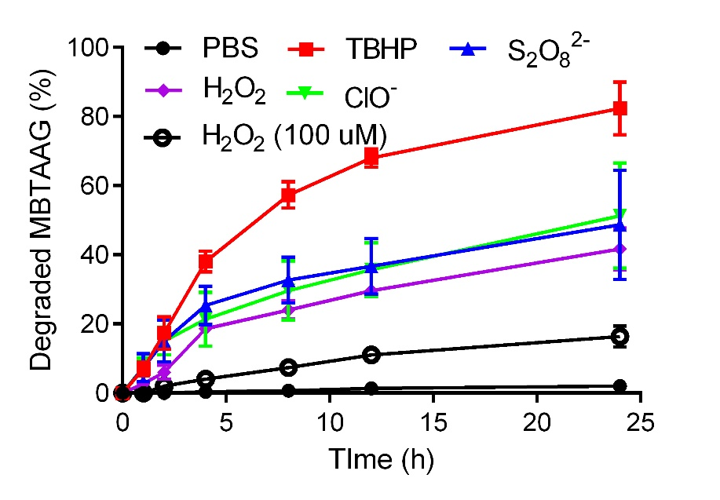
Figure S4. Percentage of MBTAAG (100 μM in PBS) degradation at 37º C in ROS species (1mM if not otherwise labeled) monitored by HPLC. PDA detector: 254 nm UV absorbance. Each sample was done in triplicate. Error bars are ± SD.
TBHP = tert-butyl hydroperoxide, S₂O₈²⁻ = ammonium persulfate, ClO⁻ = sodium hyperchloride.

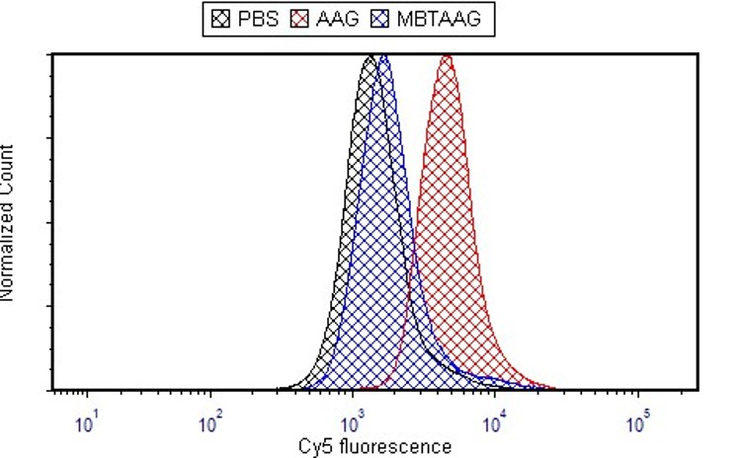
Figure S5. Flow cytometry analysis of Chinese Hamster Ovary (CHO) cell after treated with PBS, MBTAAG, AAG for 48 h.
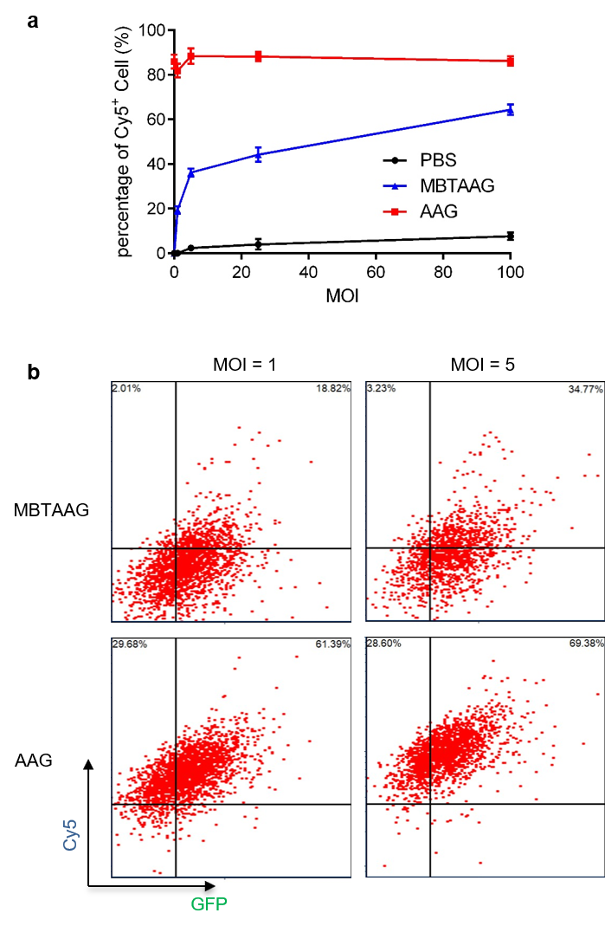
Figure S6. FACS allows separation of GFP-modified pathogen (B. subtilis.) infected RAW264.7 murine macrophages labeled with MBTAAG in a manner that correlates with the multiplicity of infection (MOI). Separation can be accomplished by both Cy5 and GFP fluorescent labels. Intracellular bacteria were selected with gentamycin (2 µg/mL).

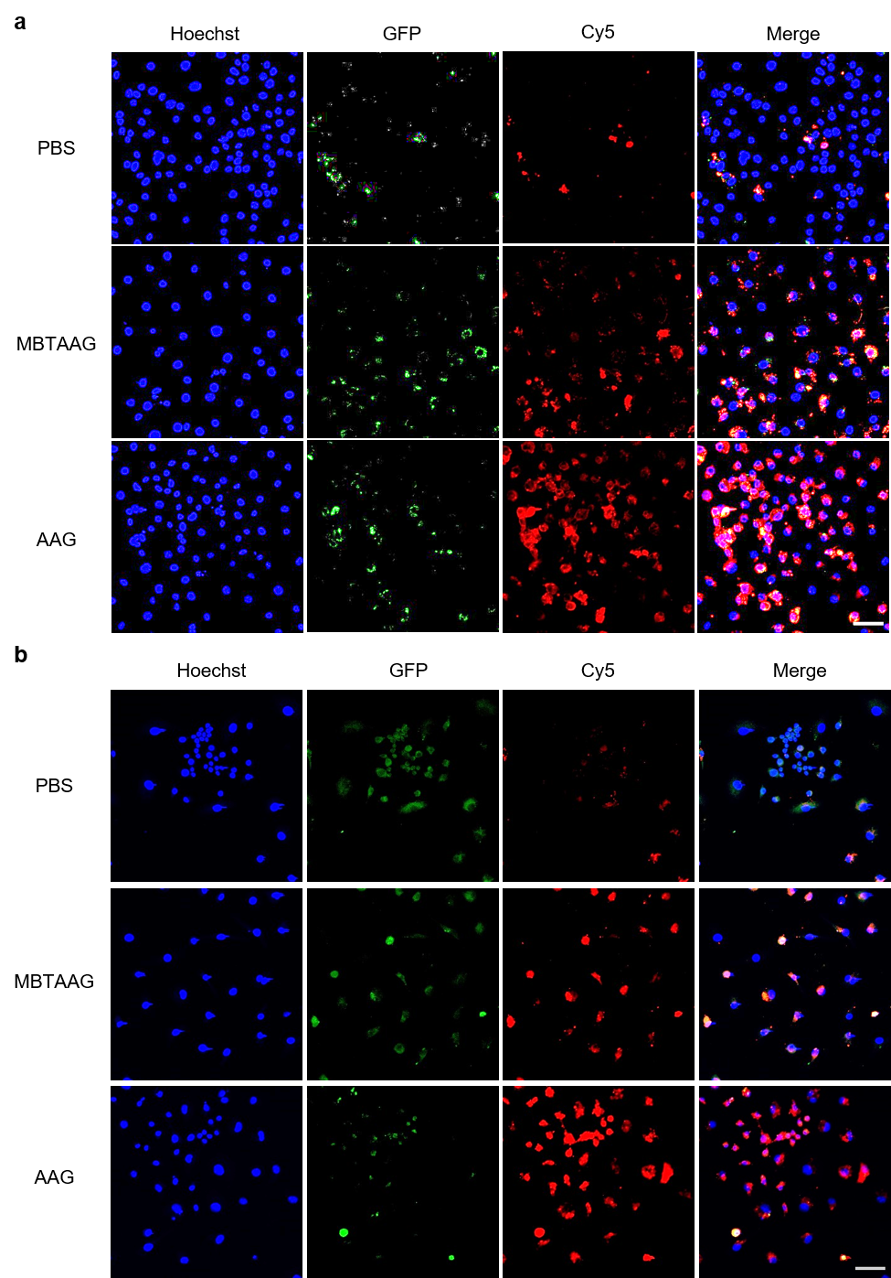
Figure S7. CLSM images of GFP-modified (green) pathogens infected macrophages from different azido sugar treated groups. RAW264.7 cells were treated with PBS, MBTAAG, AAG for 48 h, followed by co-incubation with Gram-negative pathogens E.coli (a) or Gram-positive pathogens B. Subtilis. (b) for 12 h. 2 µg/mL gentamycin was applied to select intracellular pathogens and labeled with DBCO-Cy5 (20 µM) for 1 h. Cell nuclei were stained with Hoechst 33342 (blue). Scale bar, 50 µm.
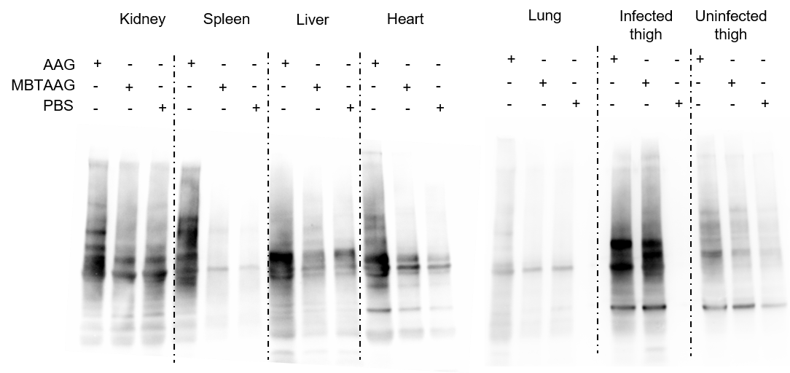
Figure S8: MBTAAG mediated infected tissue-selective labeling biodistribution. MBTAAG (76.8 mg/kg), AAG (64.0 mg/kg) or PBS was i.v. injected BALB/c mice 12 h post induced myositis by intramuscularly administration of 10⁶ CFU E. Coli at the left thigh. After 12 h post injection of MBTAAG, the metabolic biodistribution of azido groups in tissues was analyzed by western blotting. Tissue lysates were incubated with DBCO-PEG₄-biotin and then detected by streptavidin-horseradish peroxidase conjugate.

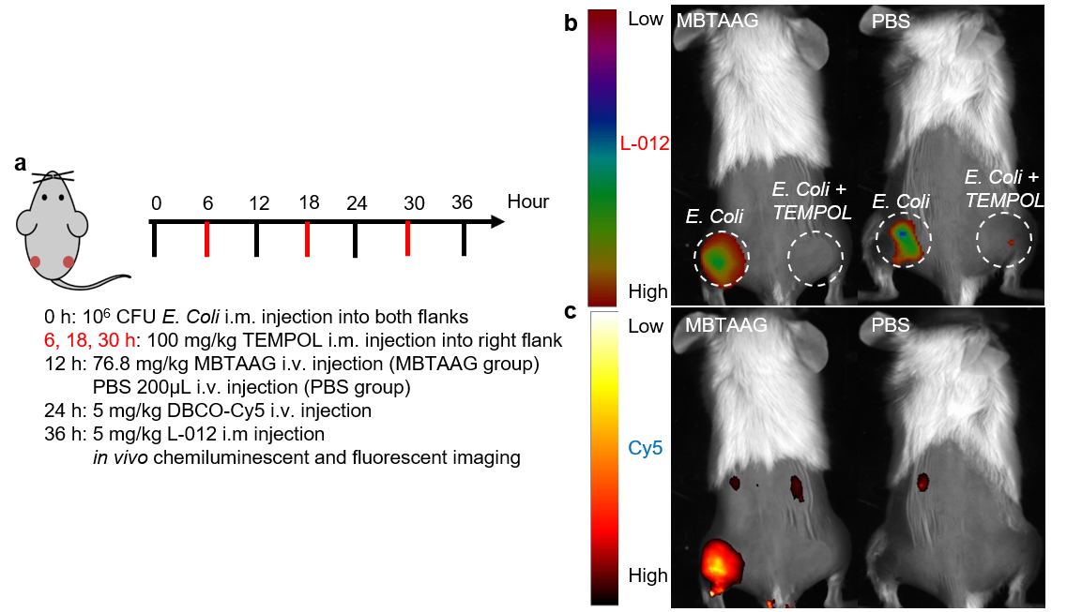
Figure S9. a) Time frame of in vivo imaging study. After 12 hours post intramuscularly injection of 10⁶ CFU E.coli into the muscle of the thigh on both flanks, the hairs over thigh and back area were shaved and depilated, and MBTAAG (76.8 mg/ kg) was i.v. injected while PBS injection was the control group. DBCO-Cy5 i.v. injection was applied to monitor the labeling of infected tissue. Radical ROS inhibitor TEMPOL was administrated intramuscularly into right flank. L-012 was i.v. injected before chemiluminescent imaging. b) In vivo whole-body chemiluminescence imaging of BALB/c mice at 10 min post injection of L-012 at both flanks c) In vivo whole-body fluorescence imaging of BALB/c mice at 12 h post injection of DBCO-Cy5.

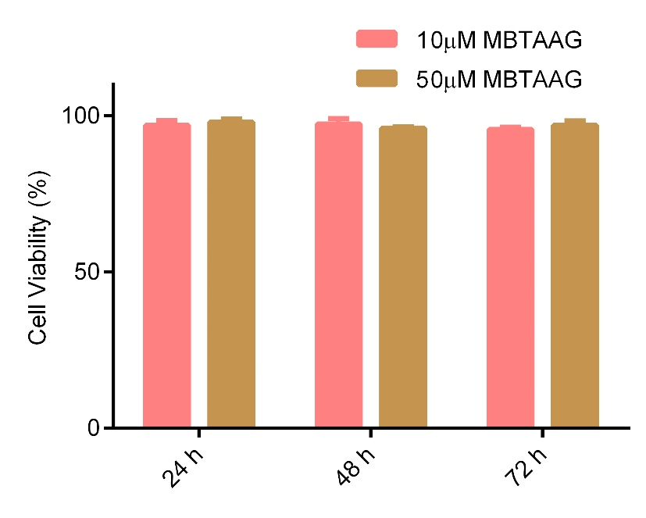
Figure S10. Trypan blue cytotoxicity assay for MBTAAG in Raw264.7 cells over 24, 48, and 72 hours. Each sample was done in triplicate. Error bars are ± SD.

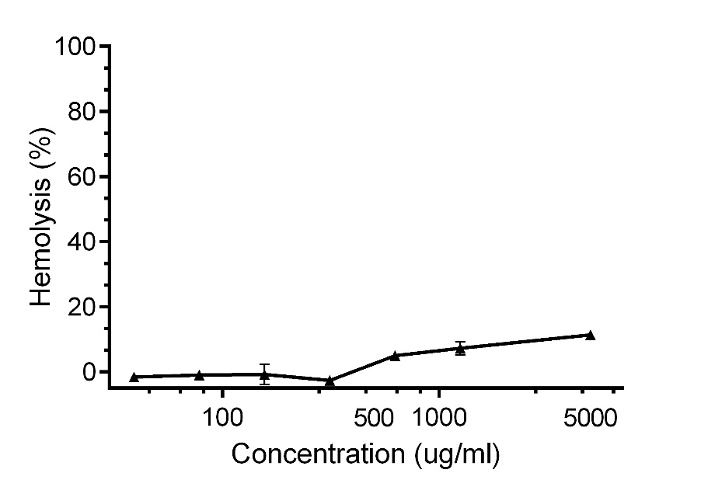
Figure S11. Hemolysis of human red blood cells treated with MBTAAG. HC50 is defined as the lowest concentration causes 50% of hemolysis.

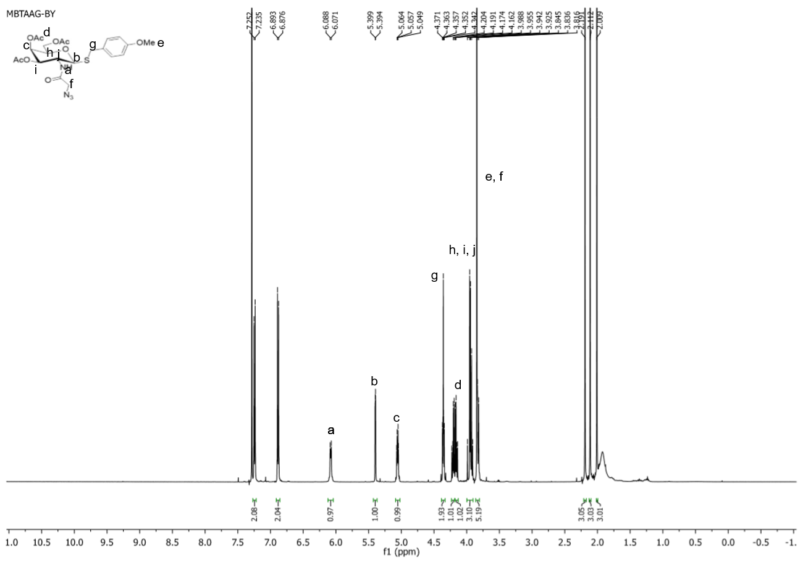
Figure S12. ¹H NMR of MBTAAG

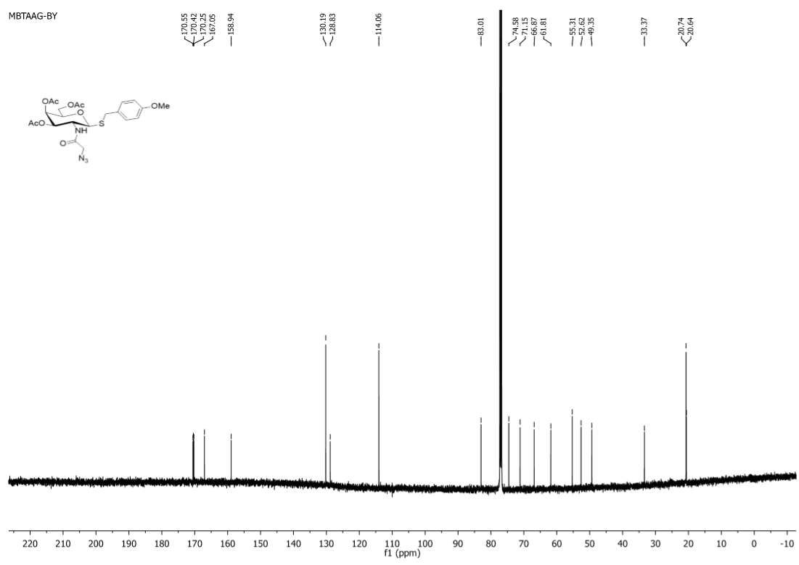
Figure S13. ¹³C NMR of MBTAAG

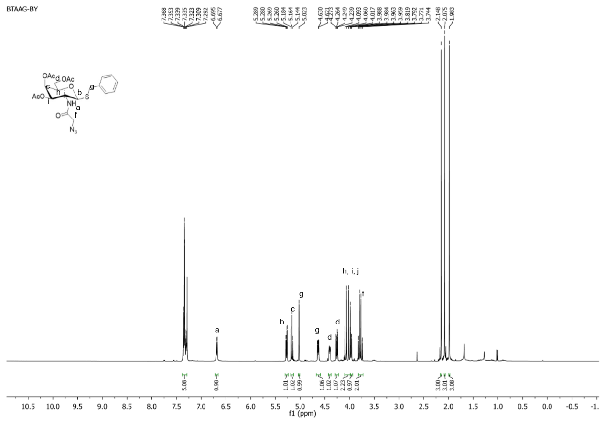
Figure S14. ¹H NMR of BTAAG

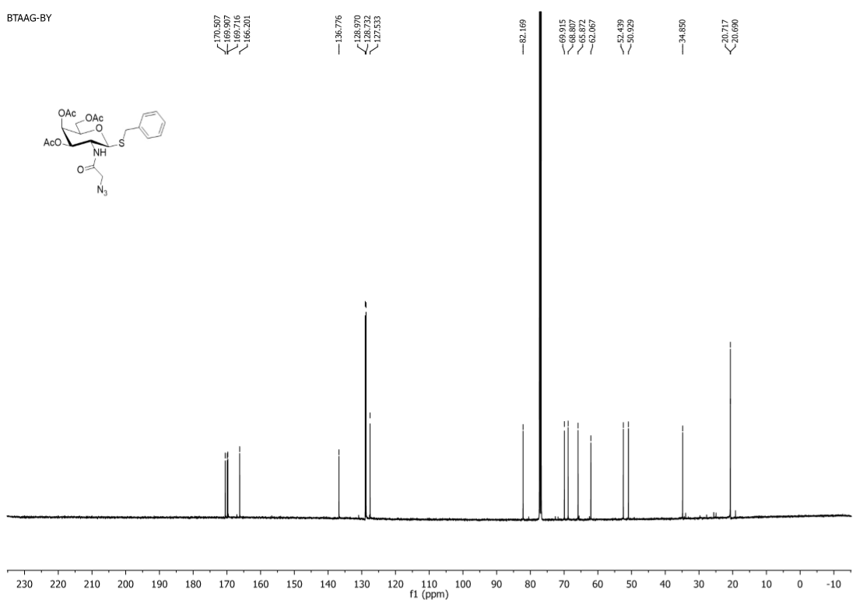
Figure S15. ¹³C NMR of BTAAG

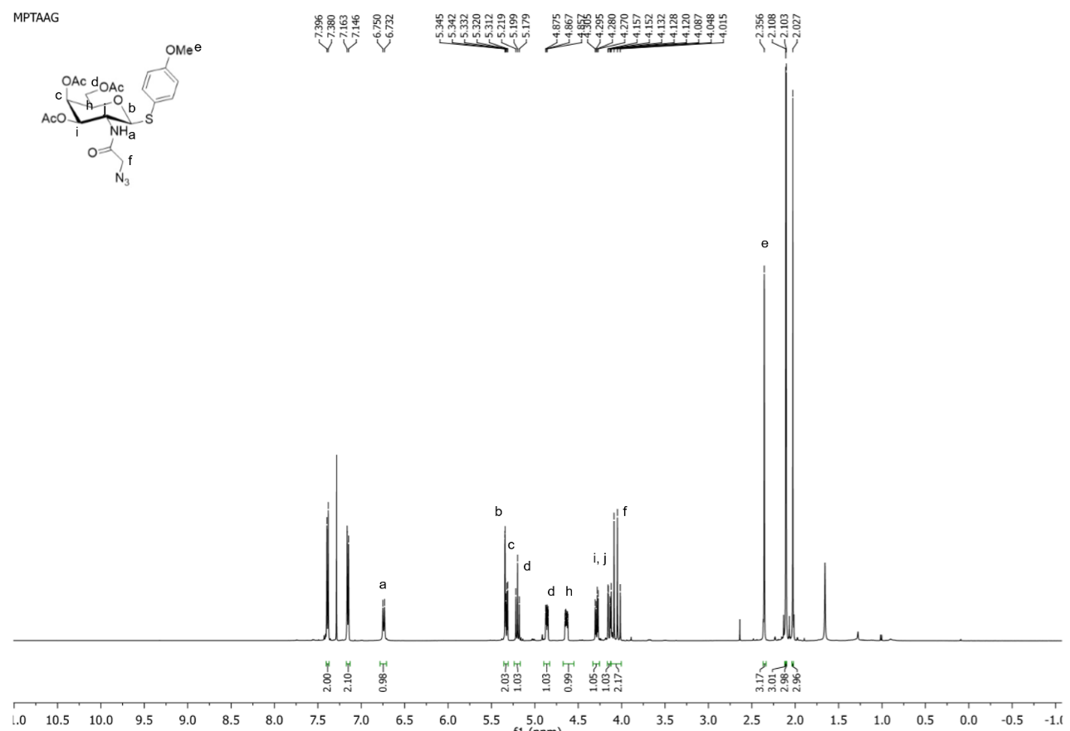
Figure S16. ¹H NMR of MPTAAG

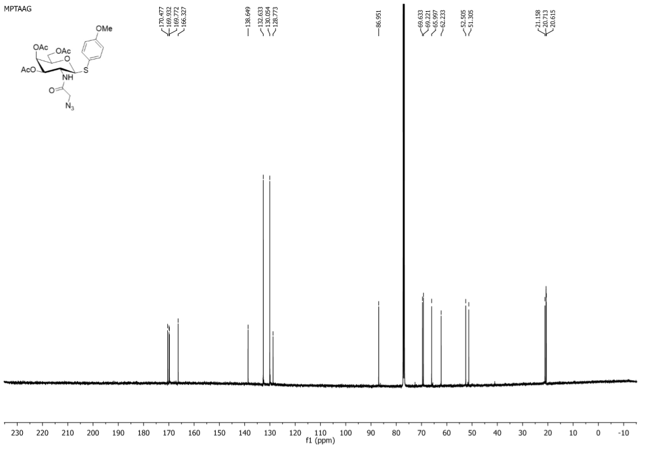
Figure S17. ¹³C NMR of MPTAAG

References.
1. Wang, H.; Wang, R.; Cai, K.; He, H.; Liu, Y.; Yen, J.; Wang, Z.; Xu, M.; Sun, Y.; Zhou, X.; Yin, Q.; Tang, L.; Dobrucki, I. T.; Dobrucki, L. W.; Chaney, E. J.; Boppart, S. A.; Fan, T. M.; Lezmi, S.; Chen, X.; Yin, L.; Cheng, J., Selective in vivo metabolic cell-labeling-mediated cancer targeting. Nat Chem Biol 2017, 13, (4), 415-424.

