**Supplementary Information**

**In Vivo Cancer Targeting via Glycopolyester Nanoparticle Mediated Metabolic Cell Labeling Followed by Click Reaction**

Hua Wanga,1, Yang Boa,1, Yang Liua, Ming Xua*,* Kaimin Caia, Ruibo Wanga, Jianjun Chenga,b*

aDepartment of Materials Science and Engineering, bDepartment of Bioengineering, University of Illinois at Urbana-Champaign, Urbana, Illinois 61801, United States

*Corresponding Author: [jianjunc@illinois.edu](mailto:jianjunc@illinois.edu)

**Materials and Methods**

**Materials.** D-Mannosamine hydrochloride and other materials were purchased from Sigma-Aldrich (St. Louis, MO, USA) unless otherwise noted. *N*-hydroxysuccinimide (NHS) was purchased from Acros Organics (Renningen, Germany). DBCO-Cy5 was purchased from KeraFAST Inc (Boston, MA, USA). EZ-Link phosphine-PEG3-biotin, streptavidin-horseradish peroxidase (HRP), and Pierce ECL western blotting substrate were purchased from Thermo Fisher Scientific (Waltham, MA, USA). DBCO-NHS was purchased from Conju-Probe (San Diego, CA, USA). Doxorubicin hydrochloride was purchased from Cayman Chemical Company (Ann Arbor, MI, USA). Monomethoxy poly(ethylene glycol) (5 k) was purchased from Polyscience (Warrington, PA, USA). Anhydrous dichloromethane (DCM), hexane, tetrahydrofuran (THF) and dimethylformamide (DMF) were purified by passing them through alumina columns and kept anhydrous by storing them in the presence of molecular sieves. Spectra/Por 6 dialysis tubing (MWCO 3.5 k or 5 k) was purchased from Spectrum Laboratories Inc (Rancho Dominguez, CA, USA). Phosphate-Buffered Saline (PBS) and Dulbecco’s Modified Eagle Medium (DMEM) were obtained from Invitrogen (Carlsbad, CA, USA). LS174T colon cancer cell line was purchased from American Type Culture Collection (Manassas, VA, USA). Fetal Bovine Serum (FBS) was obtained from Lonza Walkersville Inc (Walkersville, MD, USA). 96 well BD Falcon culture plates were purchased from Thermo Fisher Scientific (Waltham, MA, USA). ProLong Gold antifade reagent was purchased from Life Technologies (Carlsbad, CA, USA). Female 01B74 athymic nude mice were purchased from Charles River (Wilmington, MA, USA). Feed and water were available ad libitum. Artificial light was provided in a 12/12 hour cycle. The animal study protocol was reviewed and approved by the Illinois Institutional Animal Care and Use Committee (IACUC) of University of Illinois at Urbana-Champaign.

**Measurements.** Nuclear magnetic resonance (NMR) analyses were conducted on a Varian U500 (500 MHz) or a VXR500 (500 MHz) spectrometer. The molecular weights of prepared polyesters were determined by gel permeation chromatography (GPC) equipped with an isocratic pump (Model 1100, Agilent Technology, Santa Clara, CA, USA), a DAWN HELEOS multi-angle laser light scattering detector (MALLS detector, Wyatt Technology, Santa Barbara, CA, USA) and an Optilab rEX refractive index detector (Wyatt Technology, Santa Barbara, CA, USA). The detection wavelength of HELEOS was set at 658 nm. Separations were performed using serially connected size exclusion columns (Phenogel columns 100 Å, 500 Å, 103 Å, 104 Å, 5 μm, 300 × 7.8 mm, Phenomenex, Torrance, CA, USA) using DMF containing 0.1 M LiBr as the mobile phase. Data processing was performed with ASTRA V software (Version 5.1.7.3, Wyatt Technology). MALDI spectra were collected on a Bruker Daltonics UltrafleXtreme MALDI TOFTOF (Bruker, Billerica, MA, USA). HPLC analyses were performed on a Shimadzu CBM-20A system (Shimadzu, Kyoto, Japan) equipped with a SPD20A PDA detector (190 nm-800 nm), a RF10Axl fluorescence detector, and an analytical C18 column (Shimadzu, 3 µm, 50*4.6 mm, Kyoto, Japan). The size and size distribution of NPs were determined by ZetaPlus dynamic light scattering (DLS) detector (15 mW laser, incident beam = 676 nm, Brookhaven Instruments, Holtsville, NY, USA). Infrared spectra were recorded on a PerkinElmer 100 serial FTIR spectrophotometer. TEM images were collected on a JEOL 2100 cryo TEM. Confocal laser scanning microscopy (CLSM) images were taken on a Zeiss LSM 700 Confocal Microscope (Carl Zeiss, Thornwood, NY, USA). Flow cytometry analyses of cells were conducted with a BD FACS Canto 6-color flow cytometry analyzer (BD, Franklin Lakes, NJ, USA). In vivo and ex vivo images were taken on Bruker Xtreme In-Vivo Imaging System (Bruker, Billerica, MA, USA). Frozen tissues were embedded with optimum cutting temperature (O.C.T.) compound (Sakura Finetek USA, Torrance, CA, USA), sectioned by a Leica CM3050S Cryostat and mounted on a glass slide.

**Synthesis of** **Ac4ManAz**. Ac4ManAz was synthesized following the previously reported method.31 D-Mannosamine hydrochloride (539.1 mg, 2.5 mmol) and triethylamine (253.0 mg, 2.5 mmol) were dissolved in methanol (40 mL), followed by dropwise addition of *N*-(2-azidoacetyl) succinimide (545.0 mg, 2.75 mmol) in methanol. The mixture was stirred at room temperature for 24 h. Solvent was removed under reduced pressure and the residue was redissolved in pyridine. Acetic anhydride (10 mL) was added and the reaction mixture was stirred at room temperature for another 24 h. After removal of the solvent, the crude product was purified by silica gel column chromatography using ethyl acetate/hexane (1/1, v/v) as the eluent to yield a white solid (45% yield, 484.5 mg). LRMS (ESI) *m/z*: calculated for C16H22N4O10Na [M + Na]+ 453.1, found 453.1. 1H NMR (CDCl3, 500 MHz): δ (ppm) 6.66&6.60 (d, *J*= 9.0 Hz, 1H, C(O)N*H*CH), 6.04&6.04 (d, 1H, *J*=1.9 Hz, NHCHC*H*O), 5.32-5.35&5.04-5.07 (dd, *J*=10.2, 4.2 Hz, 1H, CH2CHC*H*CH), 5.22&5.16 (t, *J*=9.9 Hz, 1H, CH2CHCHC*H*), 4.60-4.63&4.71-4.74 (m, 1H, NHC*H*CHO), 4.10-4.27 (m, 2H, C*H*2CHCHCH), 4.07 (m, 2H, C(O)C*H*2N3), 3.80-4.04 (m, 1H, CH2C*H*CHCH), 2.00-2.18 (s, 12H, C*H*3C(O)). 13C NMR (CDCl3, 500 MHz): δ (ppm) 170.7, 170.4, 170.3, 169.8, 168.6, 168.3, 167.5, 166.9, 91.5, 90.5, 73.6, 71.7, 70.5, 69.1, 65.3, 65.1, 62.0, 61.9, 52.8, 52.6, 49.9, 49.5, 21.1, 21.0, 21.0, 20.9, 20.9, 20.9, 20.8.

**Synthesis of Ac3ManAzOH**. Ac4ManAz (0.15 mmol, 64.5 mg) was dissolved in anhydrous THF/methanol (2/1, v/v), followed by addition of ammonium carbonate (0.17 mmol, 18.2 mg). The reaction mixture was purged with nitrogen for 5 min and tightly capped. The mixture was stirred at 40oC for 48 h. Solvent was then removed under reduced pressure and the crude product was purified by silica gel column chromatography using hexane/ethyl acetate (1/1, v/v) as the eluent to yield a white solid (30% yield, 17.5 mg). LRMS (ESI) *m/z*: calculated for C14H20N4O9Na [M + Na]+ 411.1, found 411.1. 1H NMR (CDCl3, 500 MHz): δ (ppm) 6.56 (d, *J* = 9.2 Hz, 1H), 5.44 (dd, *J* = 10.1, 4.2 Hz, 1H), 5.22 (s, 1H), 5.18 (t, 1H), 4.63 (ddd, *J* = 9.2, 4.2, 1.8 Hz, 1H), 4.31 – 4.01 (m, 5H), 3.74 (m, 1H), 2.14&2.08&2.05 (s, 9H). 13C NMR (CDCl3, 500 MHz): δ (ppm) 171.0, 170.4, 170.1, 167.1, 93.4, 69.2, 68.4, 66.0, 62.5, 52.7, 50.9, 21.1, 21.0, 20.9.

**Synthesis of allyl-OCA**. The procedures were slightly modified from literature. Boc-L-tyrosine (30.0 mmol) and potassium carbonate (90.0 mmol) were suspended in anhydrous DMF (60 mL), followed by dropwise addition of allyl bromide (90.0 mmol) on an ice bath. The mixture was stirred at room temperature for 24 h. Water (150 mL) was added and the mixture was extracted with ethyl ether (150 mL × 3). The combined organic phase was dried over anhydrous sodium sulfate and concentrated to yield light yellow oil, which was then redissolved in dioxane and purged with HCl gas flow. After 24 h, the solvent was removed under reduced pressure and a yellow solid was obtained. The resulting yellow solid was dissolved in methanol/H2O (1/1, v/v, 100 mL) containing NaOH (90.0 mmol) and stirred at room temperature for 24 h. pH of the reaction mixture was adjusted to 7.0, cooled down at 0oC for 4 h, and the white precipitate was collected. Dried white powder (20.0 mmol) was dissolved in a mixture of sulfuric acid (40 mL, 1M) and acetonitrile (40 mL), followed by dropwise addition of sodium nitrite (40.0 mmol) in water (20 mL). The mixture was stirred under nitrogen for 24 h and then extracted with DCM (150 mL × 3). The solvent was removed to yield a yellow solid, which was then dissolved in anhydrous THF. After purging with nitrogen for 5 min, phosgene (40.0 mmol) was added dropwise on an ice bath and the mixture was stirred at room temperature for 24 h. After removal of the solvent, the crude product was purified by silica gel column chromatography using DCM as the eluent, and further recrystallized in hexane/DCM to yield a crystalline solid (overall yield in the last two steps: 60%). 1H NMR (CDCl3, 500 MHz): δ 7.13 (d, 2H, Ph), 6.88 (d, 2H, Ph), 6.05 (m, 1H, OCH2C*H=*CH2), 5.43-5.28 (ddd, 2H, OCH2CH=C*H*2), 5.26 (t, 1H, C*H*CH2Ph), 4.52 (d, 2H, OC*H*2CH*=*CH2), 3.33-3.17 (ddd, 2H, CHC*H*2Ph). 13C NMR (CDCl3, 500 MHz): 166.7, 158.8, 148.2, 133.2, 131.1, 123.6, 118.1, 115.5, 80.3, 69.0, 35.8. LRMS (ESI) *m/z*: calculated for C13H13O5 [M + H]+ 249.1, found 249.1.

**Scheme S1. Synthetic route of Ac3ManAzOH**.



**Scheme S2. Synthetic route of allyl-OCA**





**Figure S1**. 1H NMR spectrum of Ac4ManAz (a) and Ac3ManAzOH (b) in CDCl3.

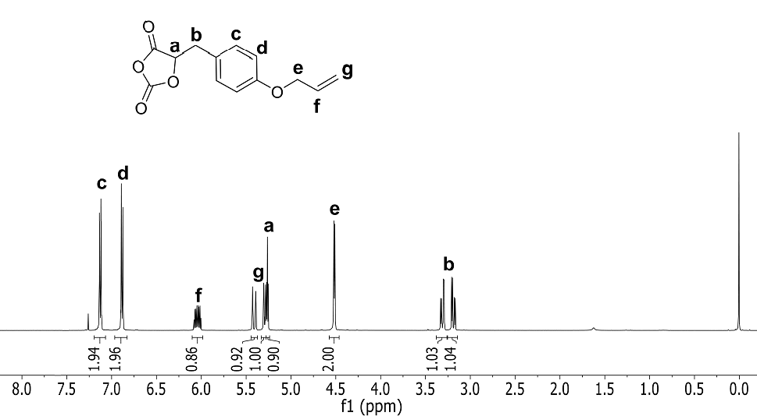

**Figure S2**. 1H NMR spectrum of allyl-OCA in CDCl3.

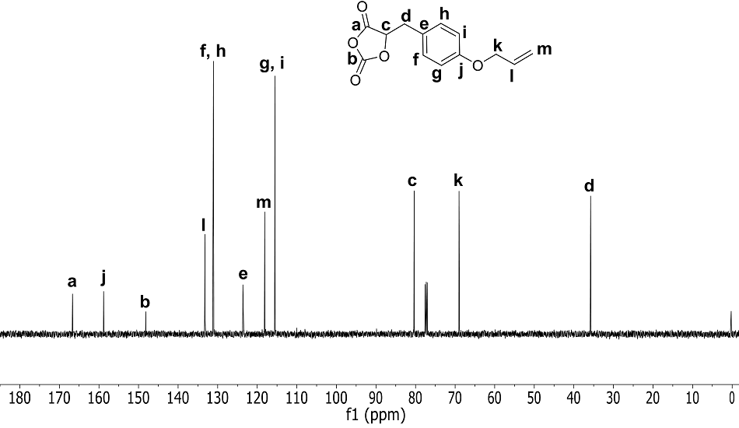

**Figure S3**. 13C NMR spectrum of allyl-OCA in CDCl3.

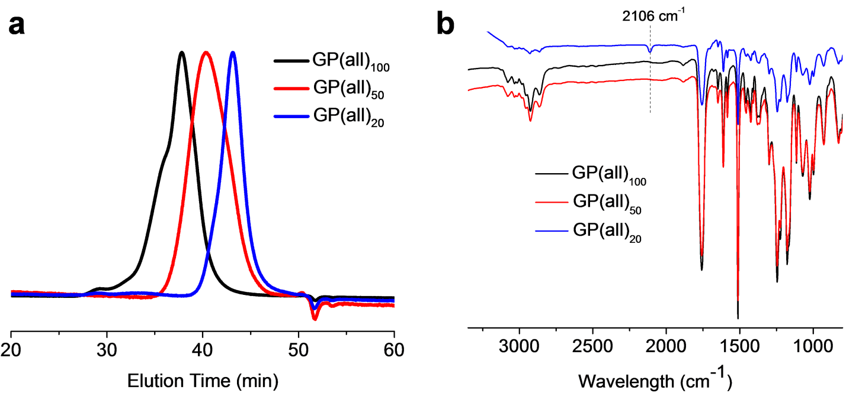

**Figure S4**. (a) GPC and (b) FTIR profiles of GP(all)100, GP(all)50, and GP(all)20, respectively.

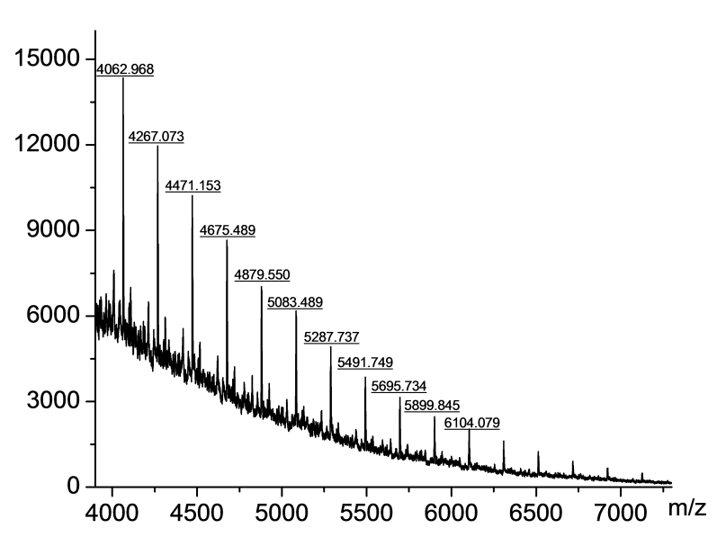

**Figure S5**. MALDI mass spectrum of GP(all)20. The observed peaks matched well with calculated values: 388.1 + 204.1*n + [H].

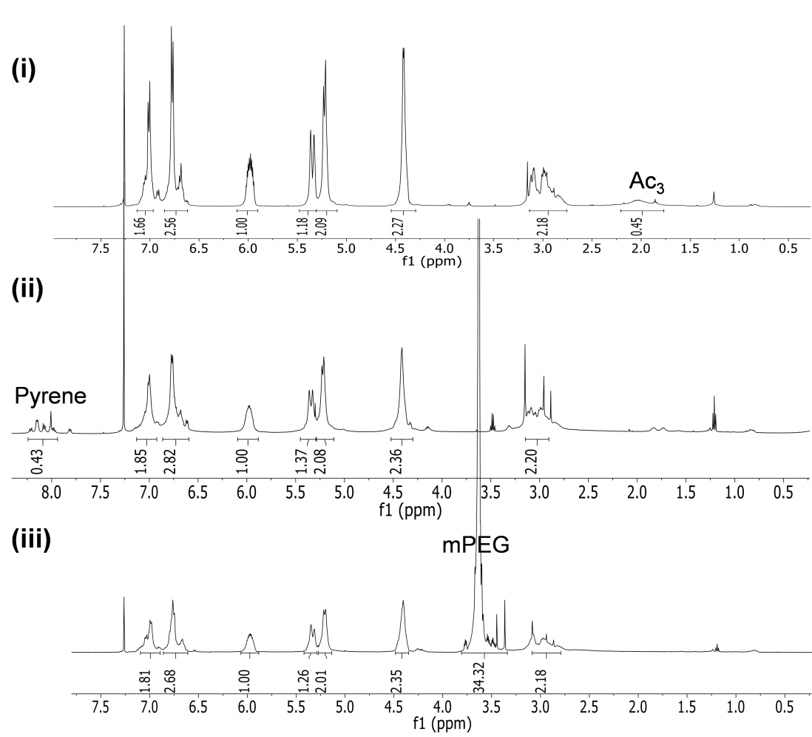

**Figure S6**. 1H NMR spectra (i) of GP(all)20, (ii) PP(all)20, and (iii) mPEG5k-P(all)20, respectively in CDCl3.

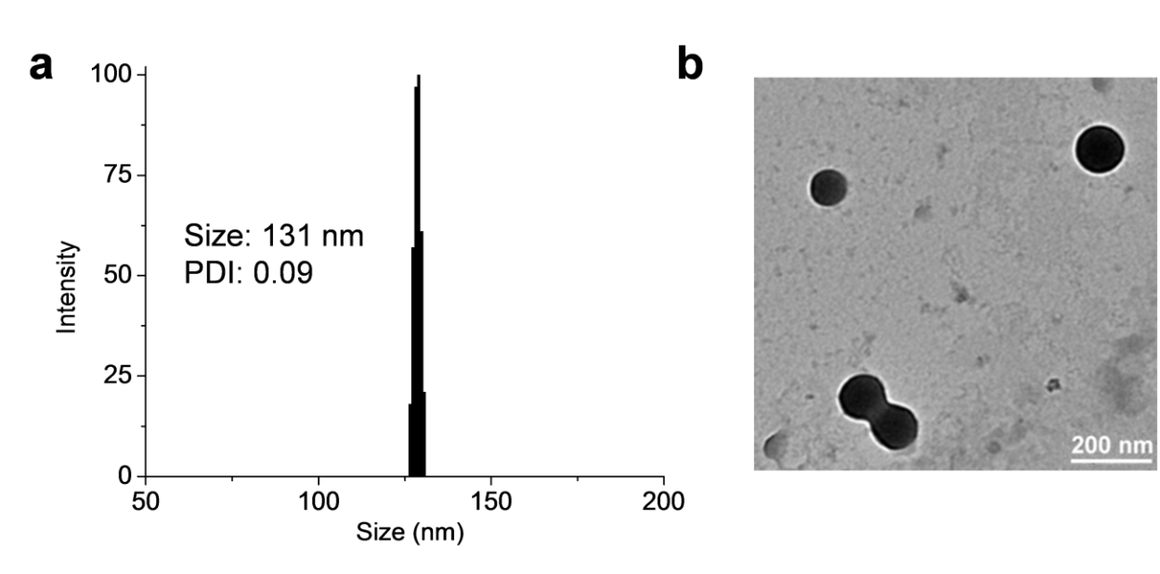

**Figure S7**. (a) DLS and (b) TEM characterizations of PP-NP prepared from coprecipitation of PP(all)20 and mPEG5k-P(all)20.

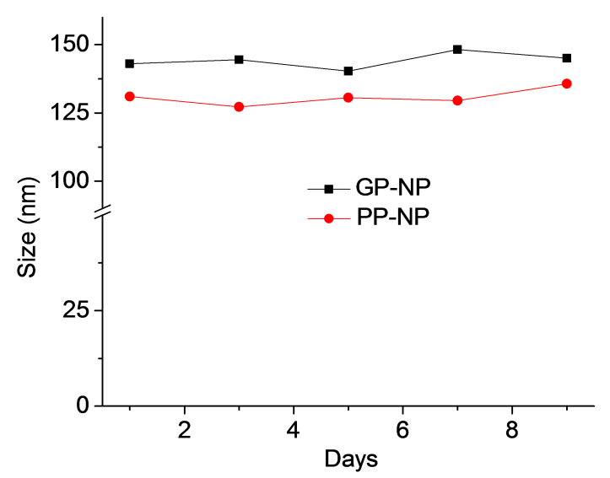

**Figure S8**. Size changes of GP-NP and PP-NP, respectively over time in 50% human serum. Size of NPs was determined by DLS.

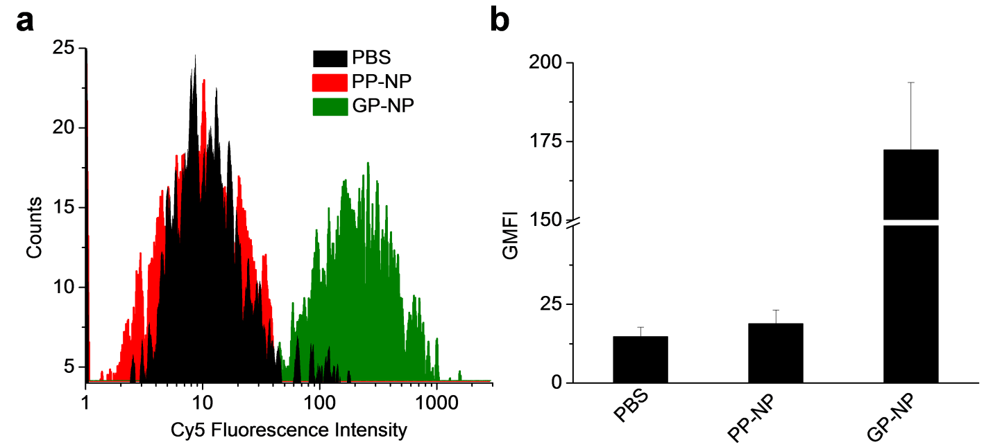

**Figure S9.** Flow cytometry (a) profiles and (b) fluorescence quantification of LS174T cells after incubated with GP-NP (25 μM), PP-NP (25 μM) and PBS, respectively for 72 h, and further labeled with DBCO-Cy5 (25 μM) for 1 h. Data were presented as average ± standard deviation, n = 3.



**Figure S10**. Pharmacokinetics of Cy5-labeled GP-NP. Mice were i.v. injected with Cy5-labeled GP-NP. Blood was collected at 0, 1, 2 , 4 , 8 , 12, and 24 h, respectively. Cy5 fluorescence in the blood was measured using the in vivo X-treme system. Data were presented as average ± standard deviation, n = 4.

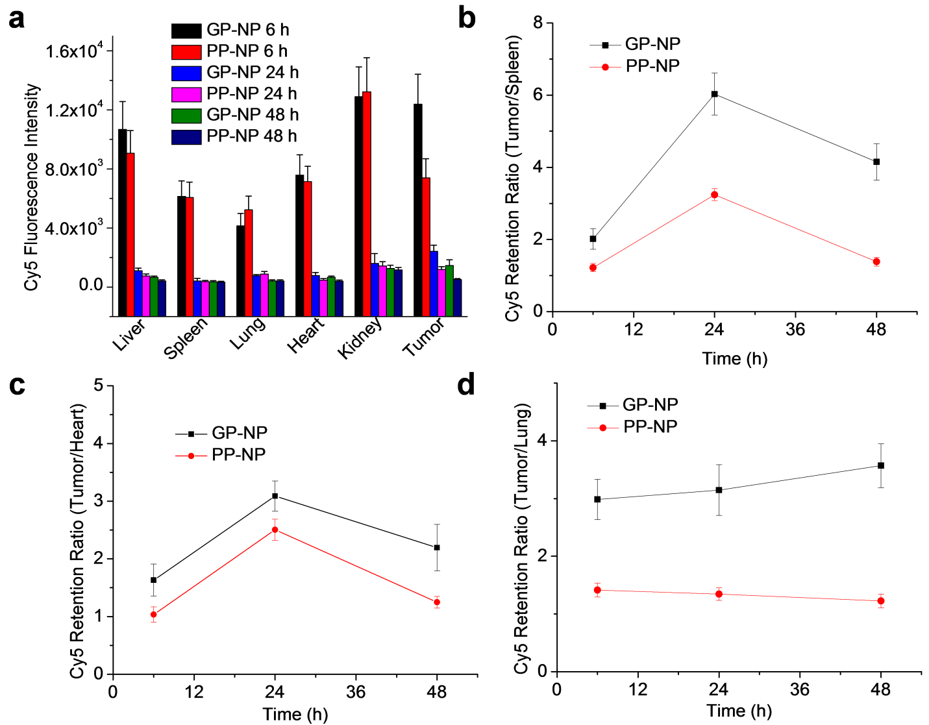

**Figure S11**. GP-NP treatment enhanced the tumor retention of DBCO-Cy5. (a) Ex vivo Cy5 fluorescence intensity of tumor and major organs at 6 h, 24 h, and 48 h p.i. of DBCO-Cy5, respectively. Cy5 retention ratio of (b) tumor to liver, (c) tumor to heart, and (d) tumor to lung over time (6 h, 24 h, and 48 h p.i.) in mice treated with GP-NP (black line) and PP-NP (red line), respectively. Data were presented as average ± standard deviation, n = 3.



**Figure S12**. Biodistribution of Cy5-labeled GP-NP at 24 and 48 h post injection. Mice bearing subcutaneous LS174T tumors were i.v. injected with Cy5-labeled GP-NP. After 24 h or 48 h, tumors and major organs were collected for analyses. The Cy5 fluorescence intensity in tissues were quantified based on a standard curve using the in vivo X-treme imaging system. Data were presented as average ± standard deviation, n = 4.



**Figure S13.** Release profile of DBCO-hz-Dox at pH 6.5, as determined by HPLC.

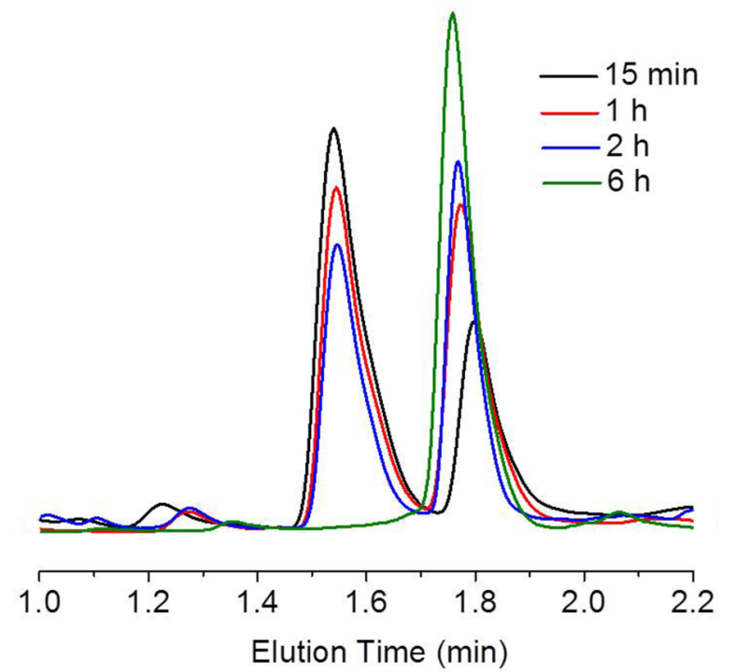

**Figure S14.** HPLC monitoring of degradation of D-D at pH 5.0. Fluorescence detector (excitation: 478 nm, emission: 590 nm) was used.



**Figure S15.** *In vitro* cytotoxicity of DBCO-hz-Dox and free Dox against LS174T colon cancer cells, as determined by MTT assay.

**Table S1**. **Ac3ManAzOH Initiated Ring-Opening Polymerization of Allyl-OCA.*a***

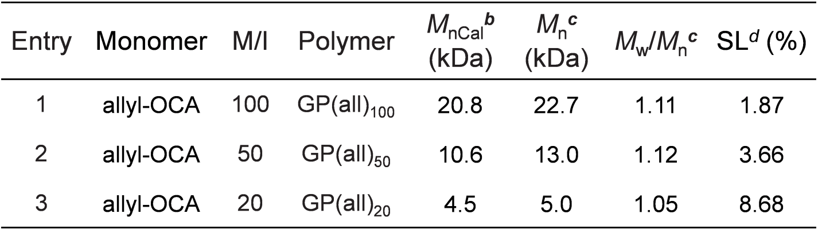

***a***DMAP and DCM were used as the catalyst and solvent, respectively. ***b***Calculated from M/I ratio with complete monomer conversion. ***c***Determined by GPC. ***d***Sugar Loading.

**Table S2. mPEG or Pyrene Initiated Ring-Opening Polymerization of Allyl-OCA.*a***

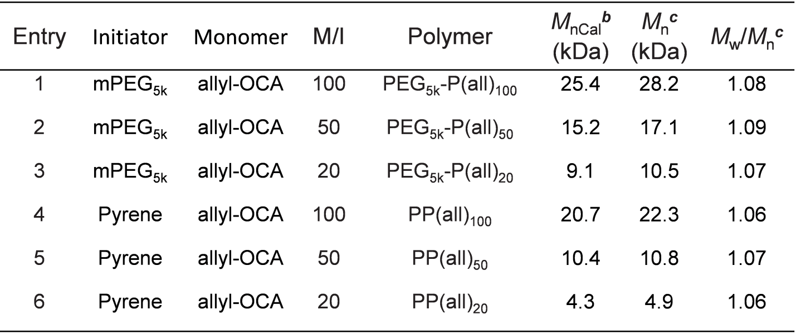

***a***DMAP and DCM were used as the catalyst and solvent, respectively. ***b***Calculated from M/I ratio with complete monomer conversion. ***c***Determined by GPC.

**References**

1. Zhang, Z.; Yin, L.; Tu, C.; Song, Z.; Zhang, Y.; Xu, Y.; Tong, R.; Zhou, Q.; Ren, J.; Cheng, J. "Redox-Responsive, Core Cross-Linked Polyester NPs". *ACS Macro Lett.* **2012**, *2*, 40-44.

2. Lu, Y.; Yin, L.; Zhang, Y.; Zhang, Z.; Xu, Y.; Tong, R.; Cheng, J. "Synthesis of Water-Soluble Poly(α-hydroxy acids) from Living Ring-Opening Polymerization of O-Benzyl-l-serine Carboxyanhydrides". *ACS Macro Lett.* **2012**, *1*, 441-444.